(Approx. 815 words)

Microsoft Releases Photosynth Panoramic Image Creator
By Ira Wilsker, APCUG Advisor; Columnist, The Examiner, Beaumont TX; radio and TV show host
Iwilsker (at) apcug.net

WEBSITE:
http://photosynth.net

This article has been obtained from APCUG with the author’s permission for publication by APCUG member groups; all other uses require the permission of the author (see e-mail address above).

Many of us take a lot of digital photographs. I have hundreds of digital photos from two recent weddings; others may have vacation photos, family photos, scenic images, or other content. Would it not be interesting if a collection of photos with some degree of commonality could be seamlessly “stitched” together creating a 3-D panoramic view of the subject? For example, if I took the wedding pictures of my daughter’s recent wedding, the images could automatically be merged into a single three dimensional, easily navigable image of the entire wedding ceremony and reception. The panoramic image can be manipulated, rotated, zoomed, and viewed from any direction. If I can do this with wedding pictures, imagine what you can do with landscapes, theme parks, or other images. This new service from Microsoft, known as Photosynth (photosynth.net) is currently free, but does have several provisos, one of which is that all images created will be considered as “public”, and can be viewed by anyone on the Photosynth website.

Photosynth is graphics intensive, and may not run on older computers lacking adequate video power and capabilities. It will run on Windows XP (SP 2 or SP3), and on Vista. Mac users can use Photosynth if running Boot Camp. Images are displayed on a browser, and Internet Explorer 7 as well as Firefox 2 and 3 are supported. 256mb of memory is the absolute minimum to run Photosynth, and 1gb is recommended. In order to function, Photosynth installs two programs to the computer. One is a web browser plug-in (both IE and Firefox compatible), and an application aptly named “Photosynth” which is used to create panoramic images. Install of both programs is fast and easy, and is accomplished with a single download. Since the actual processing is done by Microsoft, the images (or parts of them) are uploaded to Microsoft by the Photosynth software, which requires a broadband connection. Microsoft has posted a warning, “All synths are public. Your photos will be visible to everyone on the Internet. In order to create images, it is necessary to sign up online; users who have a Windows Live ID can use it for Photosynth access.

Photosynth performs two material functions; it reconstructs the scene or object from several two-dimensional digital photographs, and then examines the images for similarities, and mathematically use that information to estimate the real shape of the object, and the vantage point the photos were taken from. Using the digital data, the three dimensional space is created, and the merged photos can be easily navigated as if they were a single photograph. Microsoft’s new “Seadragon” technology delivers only the required pixels to the browser, making the loading of images that may have included hundreds of individual photos a fast and pleasing experience.

On the main page for Photosynth (photosynth.net) are dozens of samples of the output than can be created. Some of the examples are the Sphinx, composed of 239 photos taken by National Geographic; a walk around Eton College, 427 photos; The Taj Mahal, 179 National Geographic photos; the Space Shuttle, 246 photos; and many others. It is important to note that this computing power and service is available for free to all of us who are willing to make our images public. The “Recently Synthed” link shows the most recently created scenes (many dated today, as I type this), which include street scenes, still life, sunsets, Hawaiian scenery, Nathan’s Hotdog Eating Championship – 2008, backyards, portraits, kittens (cute), athletic events, and other topics. It is a lot of fun just browsing these synths and seeing what others are doing and what the system can do for digital images.

The potential applications for Photosynth are almost endless. It could be used by real estate agents to easily create an interactive three dimensional view of a house or an apartment; industries could use it for training purposes; products can be promoted via 3D images that allow the viewer to explore the details of a product; likewise car dealers and manufacturers could easily create interactive views of any cars in inventory. Criminalists (as in CSI) could easily create 3D crime scene images; the potential uses are unimaginable.

If you are willing to release your image to the public (in the current iteration), and would like to create interactive 3D panoramic photos from your digital photos, then Photosynth would be a great place to experiment. At present the service is free, only requiring a Windows Live ID registration. If you have any interesting photos of the same subject, try synthing them.

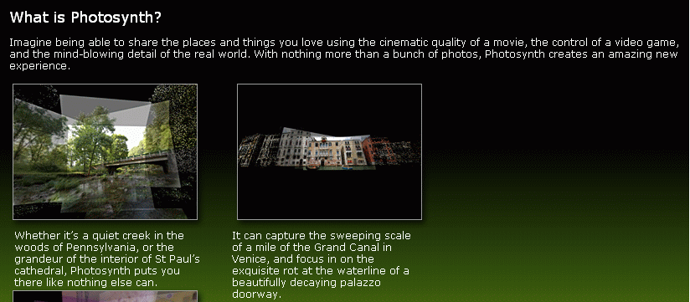
Synth1
Synth2
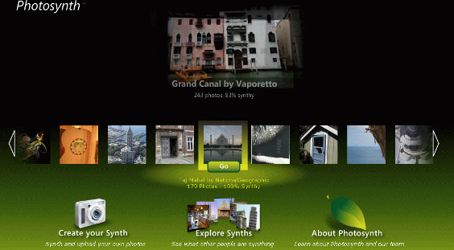

Synth3
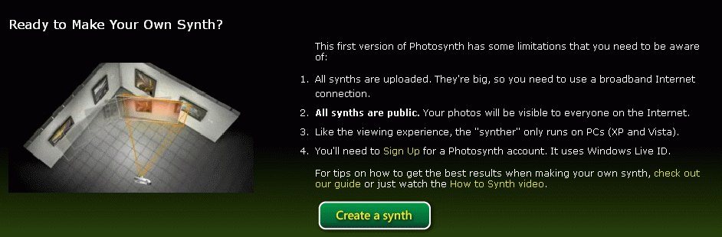

Synth4
